- Create a row vector that has the elements: 32, 4, 81, e^{2.5}, 63, cos(Π/3).and 14.12

- Create a Column vector that has the elements: 55, 14, ln(51), 987,0, and 5sin(2.5Π).

- Create a row vector in which the first element is 1, the last element is 33, with an increment of 2 between the elements (1, 3, 5,……33).

- Create a Column vector in which the first element is 15, the elements decrease with increments of -5, and the last element is -25. (A column vector can be created by the transpose of a row vector).

- Create a row vector with 15 equally spaced elements in which the first element is 7 and the last element is 40.

- Create a column vector with 12 equally spaced in which the first element is -1 and the last element is -15.

- Create a vector, name it Afirst that has 16 elements in which the first is 4 the increment is 3 and the last element is 49. Then, using the colon symbol creates a new vector; call it Asecond, that has eight elements. The first four elements are the first four elements of the vector Afirst, and the last four are the last four elements of the vector Afirst.

- Create the matrix shown below by using the vector notation
or creating vectors with constant spacing and / or the linspace command when entering the rows
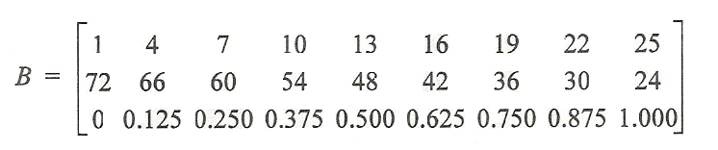

9. Create the following matrix A:
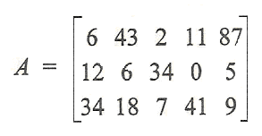
Use the matrix A to:
- Create a five element row vector named va that contains the elements of the second row of A.
- Create a three-element row vector named vb that contains the elements of the fourth column of A.
- Create a ten-element row vector named vc that contains the elements of the first and second roes of A.
- Create a six-element row vector named vd that contains the elements of the second and fifth column of A.

10). Create a following matrix C
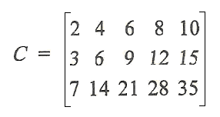
Use the matrix C to:
- Create a three element column vector named ua that contains the elements of the third column of C.
- Create a five element column vector named ub that contains the elements of the second row of C.
- Create a nine element column vector named uc that contains the elements of the first, third and fifth column of C.
- Create a ten element column vector named ud that contains the elements of the first and second row of C.

11. Create the following matrix A:
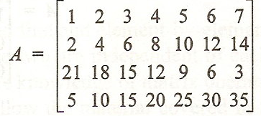
- Create a 3 X 4 matrix B from the 1st, 3rd, and 4th rows, and the 1st, 3rd through 5th and 7th columns of the matrix A.
- Create a 15 elements-long row vector u from the elements of the third row, and the 5th and 7th columns of the matrix A.

12. Using the zeros, ones, and eye commands create the following arrays:
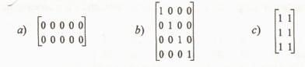

13. Using the eye command create the array A shown on the left below. Then, using the colon to address the elements in the array, change the array to be like the one shown on the right.
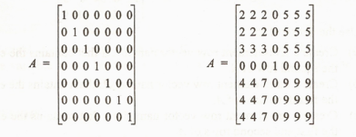

14. Using the zeros and ones commands create a 3 x 5 matrix in which the first, second, and fifth columns are 0’s, and the third and fourth columns are l’s.

15. Create a 5 x 7 matrix in which the first row are the
numbers 1 2 3 4 5 6 7, the second row are the numbers
8 9 10 1112 13 14, the third row are the numbers 15
through 21, and so on. From this matrix create a
new 3 x 4 matrix that is made from rows 2 through 4,
and columns 3 through 6 of the first matrix.

16. Create a 3 x 3 matrix A in which all the elements are 1,
and create a 2 x 2 matrix B in which all the elements
are 5. Then, add elements to the matrix A by appending
the matrix B such that A will be:
